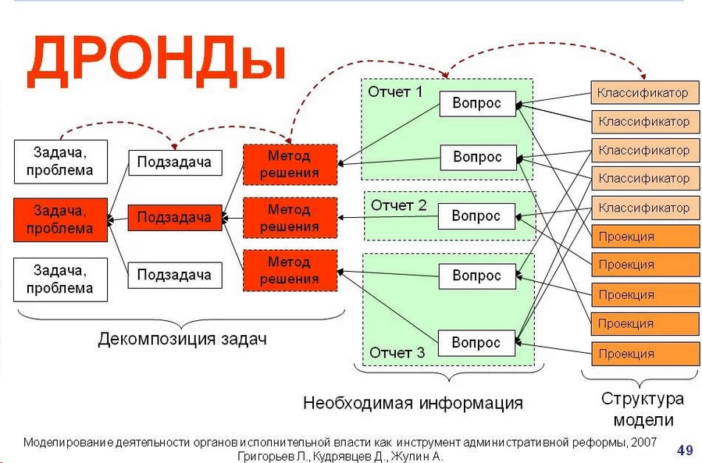

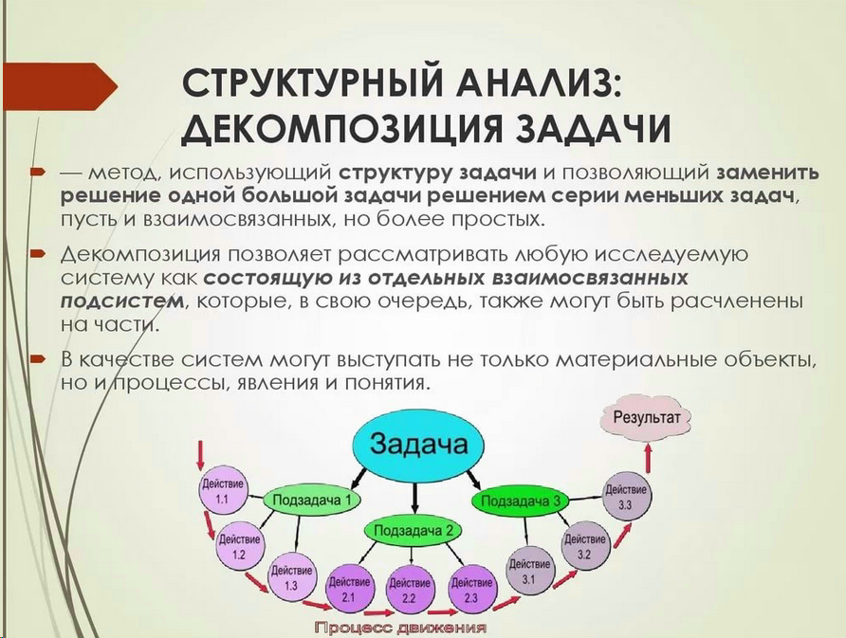

<https://yandex.ru/images/search?text=%D1%83%D0%BF%D1%80%D0%B0%D0%B2%D0%BB%D0%B5%D0%BD%D0%B8%D0%B5%20%D0%B7%D0%B0%D0%B4%D0%B0%D1%87%D0%B0%D0%BC%D0%B8%20%D0%B4%D0%B5%D0%BA%D0%BE%D0%BC%D0%BF%D0%BE%D0%B7%D0%B8%D1%86%D0%B8%D1%8F%20%D0%B7%D0%B0%D0%B4%D1%87%20%D0%B8%20%D0%BA%D0%BE%D0%BD%D1%81%D0%BE%D0%BB%D0%B8%D0%B4%D0%B0%D1%86%D0%B8%D1%8F%20%D0%BE%D1%82%D1%87%D0%B5%D1%82%D0%BE%D0%B2&stype=image&lr=213&source=wiz&pos=11&img_url=https%3A%2F%2Fcf.ppt-online.org%2Ffiles2%2Fslide%2Fc%2FC1IgdprMcROuZze0LEia9KTj7fA5WoPhyq83SXsnJm%2Fslide-7.jpg&rpt=simage>

<https://www.citeck.ru/solutions/tasks/>